Exp.5 Class A BroadBand Amplifier EXP. 5
Based on the circuit shown:
R1 = 68KΩ, R2 = 10KΩ, R3 = 10KΩ, R4 = 200Ω ( two 100Ω in series ),
R5 = 2.2KΩ, R₆ = 10KΩ, R₇ = 1KΩ
C1 = 0.1uF, C2 = 0.1 uF Q1 = 2N3904
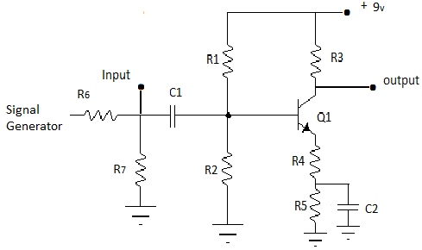
Calculate what the expected DC voltage will be at the base, V_{B} = ______;
at the emitter V_{E} = ______
at the collector, V_{C} = _______
Wire the circuit and measure these voltages, V_{B} = ______ V_{E} = ______ V_{C} = _______
If the measured values are more than +/- 20% off recheck your calculations and measurements.

EXP. 5

Set the signal generator at the input to 500mv [ 1v pk-pk]. With frequency equal to 1 KHz.
Connect one of the scopes to the collector of the transistor and record the input and output voltages.
Record voltages for the frequencies listed and calculate the voltage gain A_{v}
You may need to review the instructions for using the scope.

Frequency | V_{in} +pk | V_{in} -pk | V_{in} | V_{o} +pk | V_{o} -pk | V_{o} | A_{v}
1KHz
5KHz
10KHz
20KHz
50KHz
100KHz
500KHz
1MHz

Plot A_{v} versus frequency on semi log paper provided [ choose an appropriate vertical scale.]

EXP. 5

